A Project Report on

**E Blogs**

The Maharaja Sayajirao University of Baroda

Gujarat – India.

Submitted By:-

Riddhi Patel (539)-2014033800084133

Vrunda Patel(541)-2014033800084195

**ACKNOWLEDGEMENT:-**

This project has been a great mode of understanding and putting to the practice what was covered during the academics. It has also been a valuable experience for us in real times of real life work in the Computer Science and Engineering department which has helped to prepare us to apply ourselves better. Of Course, all this was not possible without the support and guidance of many people, and hence, we would like this to take this opportunity to acknowledge their support towards us.

We are thankful to our project guide Mr. Viral Kapadia for his invaluable encouragement and inspiration and for being a great guide throughout the project.

During this project we have received immense support and assistance from all the intellectual and helpful colleagues. Our heartfelt thanks to all our colleagues and we wish them the best for their future. Apart from this, we wish to acknowledge our academics tutors who have mentored us throughout.

TABLE OF CONTENT

1. PROJECT PROFILE

**1.1 INTRODUCTION**

**1.2 FEATURES**

**1.3 MODULE**

2. TOOLS AND TECHNOLOGIES USED

**2.1 TOOLS USED**

**2.2 TECHNOLOGIES USED**

**2.2.1 ASP.NET**

2.2.1.1 OVERVIEW

2.2.1.2 ARCHITECTURE

2.2.1.3 FEATURES

3. SYSTEM REQUIREMENT SPECIFICATION

**3.1 FUNCTIONAL REQUIREMENT**

**3.2 NON FUNCTIONAL REQUIREMENT**

4. SYSTEM DESIGN

**4.1 DATA FLOW DIAGRAM**

**4.2 ENTITY RELATIONSHIP DIAGRAM**

5. SCREEN SHOTS

6. DATA DICTIONARY

**1. PROJECT PROFILE**

**1.1 INTRODUCTION**

E-Blogs stands for Electronic blogs. A blog is a blend of the term web log ,a type of website or a part of website , which is the publication of regular articles over time in some areas . This is a **Blogspot** website that allows users to read and post their blogs. You can even post questions, so that other people could answer if they are aware of it. Only registered users can create and post blogs. Blogs can be deleted and modified by users and administrators. Unregistered users are allowed only to surf, read and comment on the blogs.

**1.2 FEATURES**

The avid readers and geeks are always in search of knowledge, trying to gain from all the sources available. E-blogs can be a very useful platform for sharing knowledge as well as for gaining it.

* People can post useful information. They can follow the people and receive notifications when a new popular blog is posted by the person whom they follow.
* There are several categories included in the system like science, space, fashion, games. People can read articles from the categories which interest them.
* Articles on daily basis are posted by the admin; the user can even read those articles.
* Users can comment and post related questions, so that the people knowing them can answer them.
* People can review the blogs and the already answered questions.
* The commercial part of the blog can help the users to post advertises.

**1.3 MODULES**

1. *Admin*

* Manage the passwords, usernames of the new users.
* Manage the data of the registered users.
* Can delete the posts of the user if the content is inappropriate.
* Post the articles on daily basis.
* Notify the user about the new post to the registered user if he follows particular people (his blogs).

1. *Registered user*

* Create account for registering to post blogs.
* Read blogs and comment.
* Follow people.
* Post questions.
* Delete posts and manage profile.

1. *Unregistered user*

* Read and comment on posts.

**2. TOOLS AND TECHNOLOGIES USED**

**2.1 TOOLS**

|  |  |
| --- | --- |
| **Development Tool** | Microsoft Visual Studio 2015 |
| **Database Tool** | Microsoft SQL Server 2014 |

**2.2 TECHNOLOGIES**

**2.2.1 ASP.NET**

**2.2.1.1 OVERVIEW**

ASP.NET is a unified Web development model that includes the services necessary for you to build enterprise-class Web applications with a minimum of coding. ASP.NET is part of the .NET Framework, and when coding ASP.NET applications you have access to classes in the .NET Framework. You can code your applications in any language compatible with the common language runtime (CLR), including Microsoft Visual Basic and C#. These languages enable you to develop ASP.NET applications that benefit from the common language runtime, type safety, inheritance, and so on.

**2.2.1.2 ARCHITECTURE**

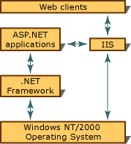

As the illustration shows, all Web clients communicate with ASP.NET applications through Microsoft Internet Information Services (IIS). IIS deciphers and optionally authenticates the request. If Allow Anonymous is set to **true**, no authentication occurs. IIS also finds the requested resource (such as an ASP.NET application), and, if the client is authorized, returns the appropriate resource.

In addition to the built-in ASP.NET security features, an ASP.NET application can use the low-level security features of the .NET Framework.

**2.2.1.3 Features**

* Bundling and minimisation Feature.
* Strongly Typed Data Controls.
* Model Binding - Isolating the Web Form from the Model.
* Value Providers.
* Support for OpenID in OAuth Logins.
* Support for improved paging in ASP.NET 4.5 GridView control.
* Enhanced support for asynchronous programming.
* Support for web sockets.
* Support for HTML5 form types.

**3. SYSTEM REQUIREMENT SPECIFICATION**

**3.1 FUNCTIONAL REQUIREMENTS**

|  |  |
| --- | --- |
| Function | User |
| Maintains the user data | **Admin** |
| Delete the blogs | **Admin** |
| Posts the blogs | **Admin** |
| Answers Questions | **Admin** |
| Decides the place ad | **Admin** |
| Delete the comments | **Admin** |

**3.2 FUNCTIONAL REQUIREMENTS**

|  |  |
| --- | --- |
| Function | User |
| Login | **Registered User** |
| Read blogs | **Registered User** |
| Surf category-wise | **Registered User** |
| Ask questions | **Registered User** |
| Comment | **Registered User** |
| Post blog | **Registered User** |
| View profile | **Registered User** |
| Send request | **Registered User** |
| Accept request | **Registered User** |
| Post ad | **Registered User** |

**3.3 FUNCTIONAL REQUIREMENTS**

|  |  |
| --- | --- |
| Function | User |
| Register | **Unregistered User** |
| Read blogs | **Unregistered User** |

**3.4 NON FUNCTIONAL REQUIREMENTS**

**Secure:** There is a user hierarchy and rights are given accordingly

**User friendly:** The GUI will be such that it can be easily learnt by all kinds of users

**Availability:** The responsive web application will allow the users to access the system anywhere and from any device with ease.

**4. SYSTEM DESIGN**

**4.1 DATA FLOW DIAGRAM**

**4.1.1 CONTEXT LEVEL**

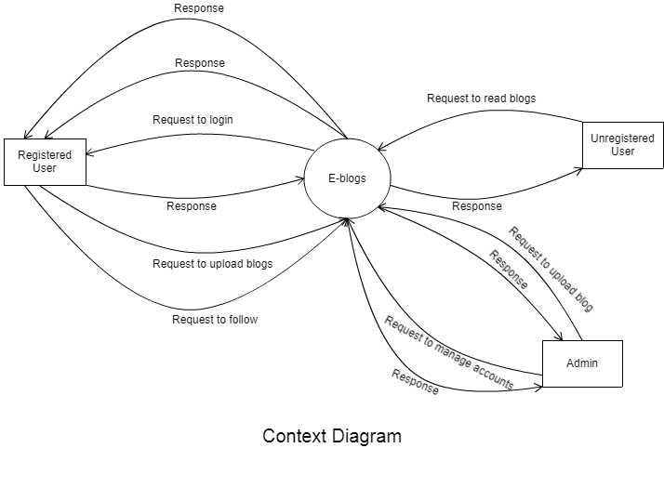**4.1.2 LEVEL 1**

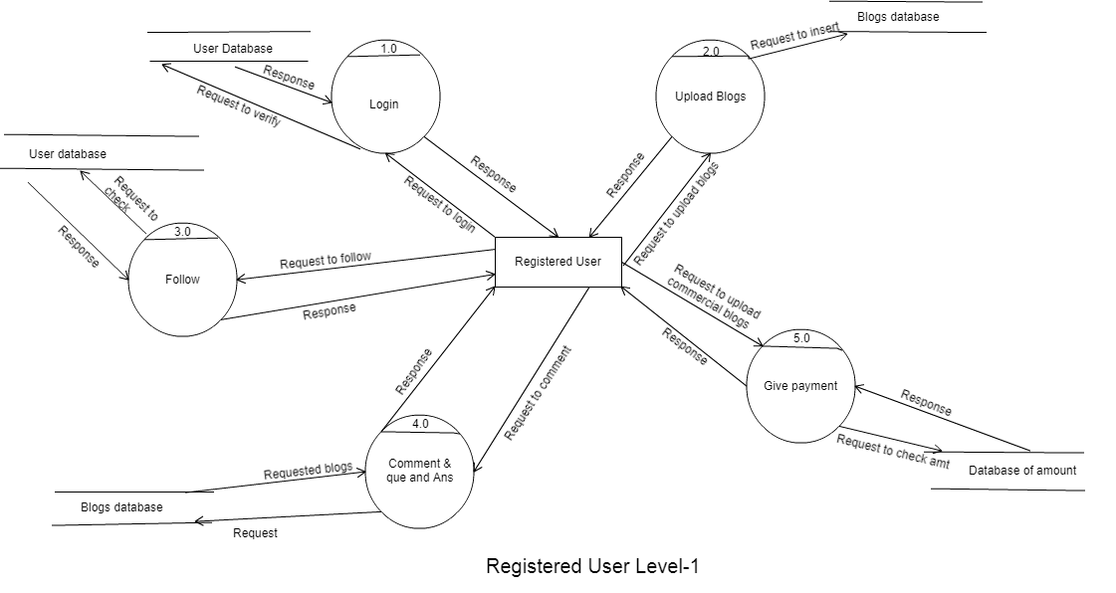

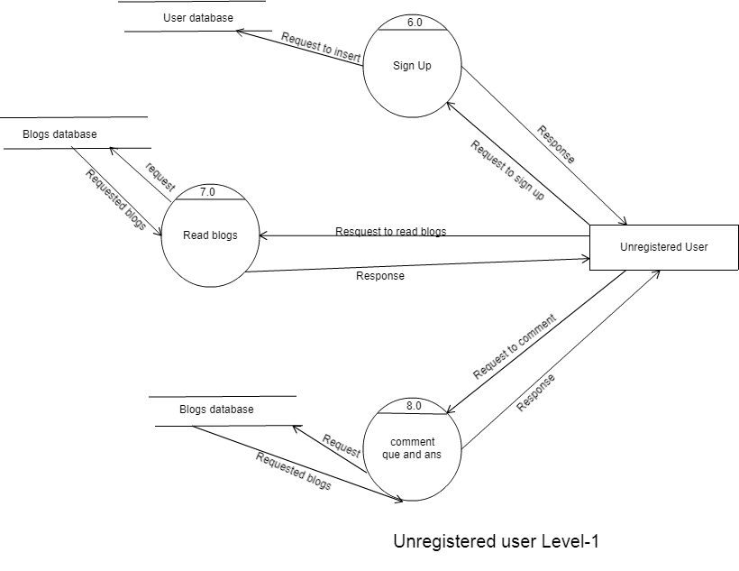

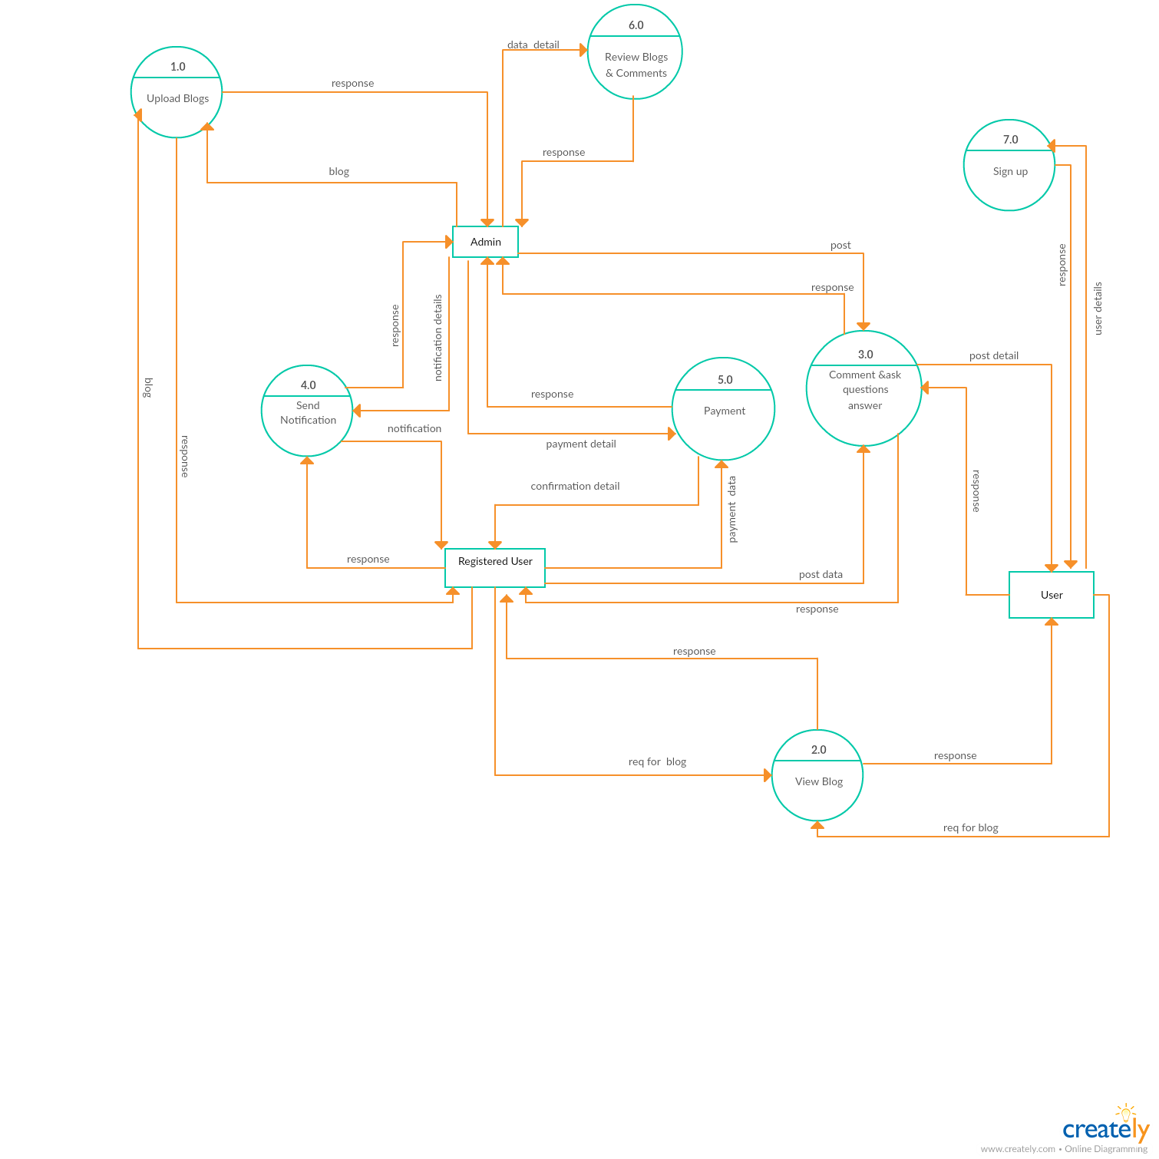

**4.1.3 LEVEL 2**

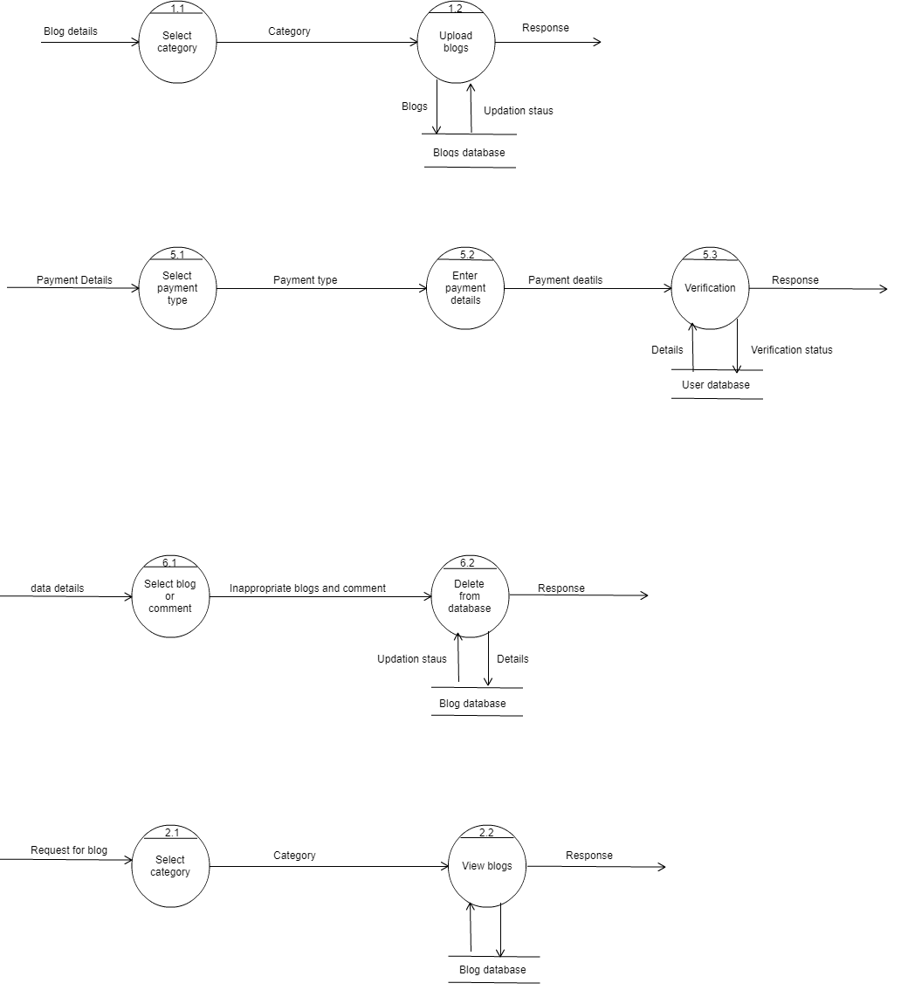

**4.2 USECASE DIAGRAM**

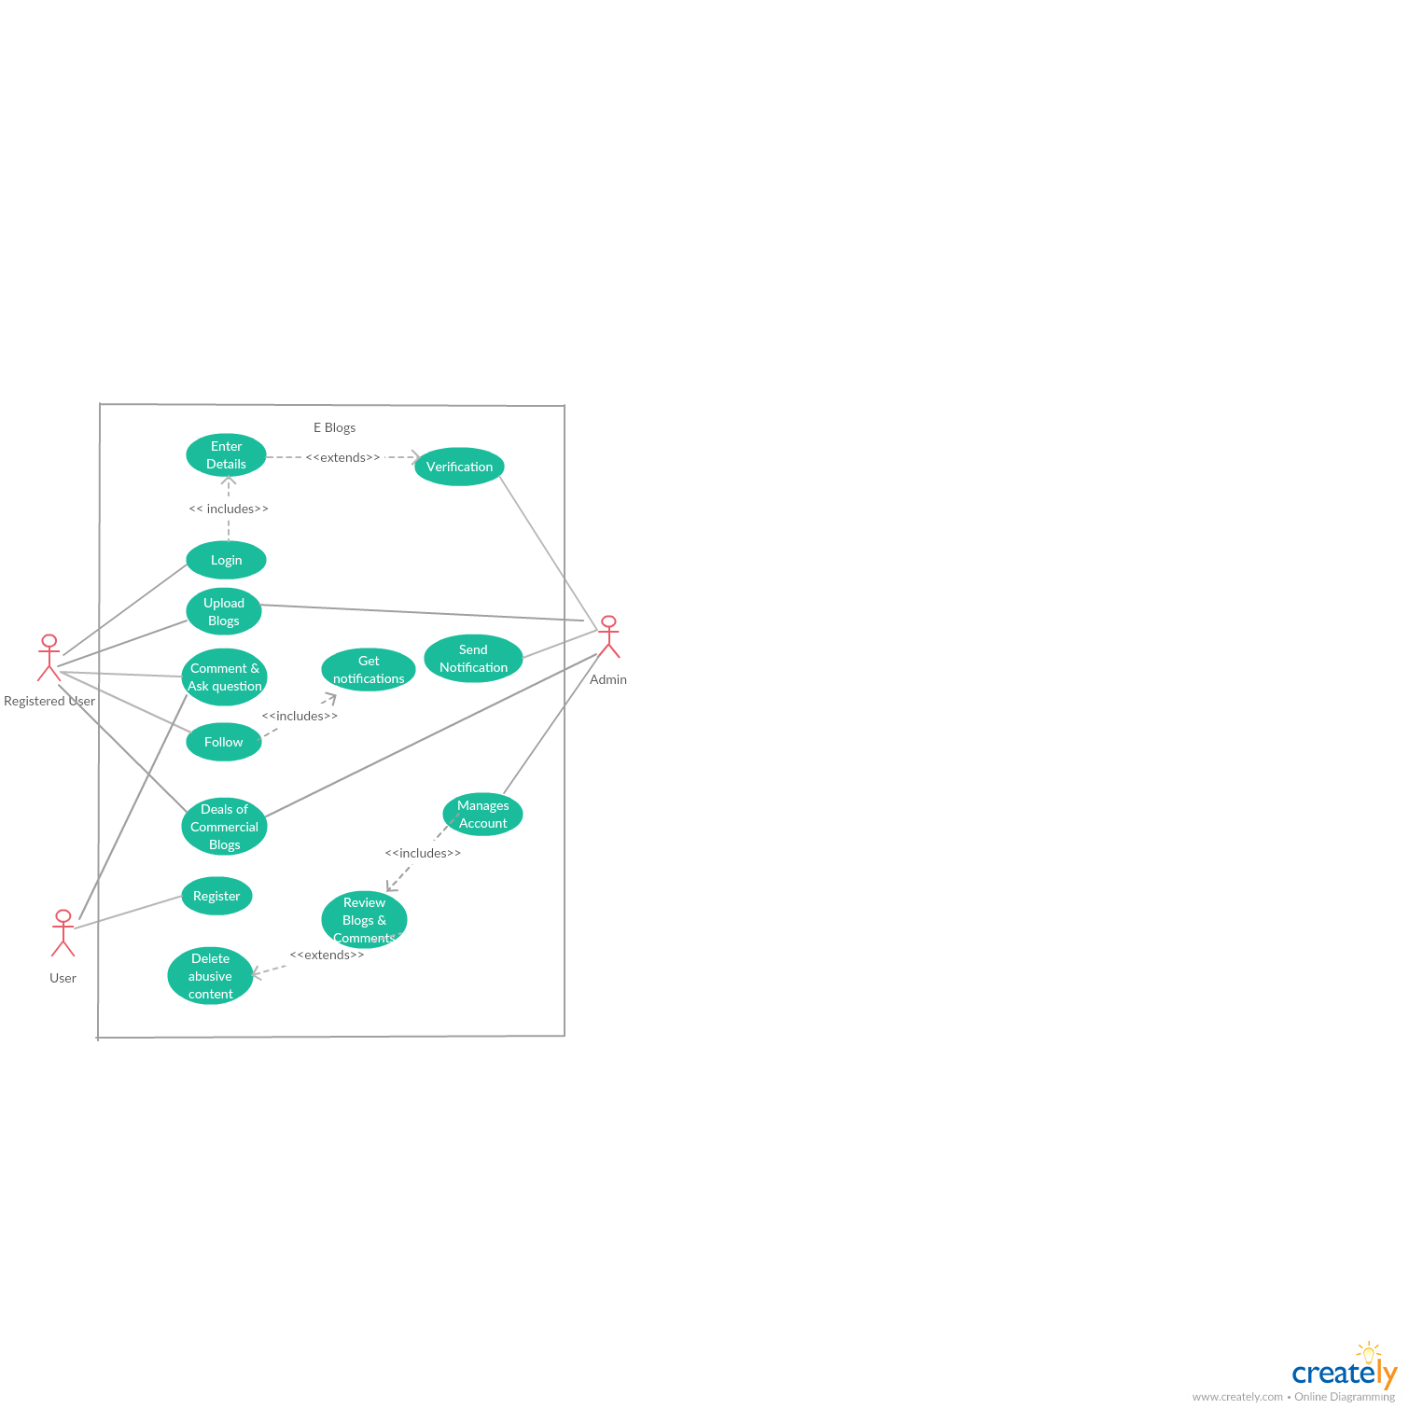

**4.3 ENTITY RELATIONSHIP DIAGRAM**

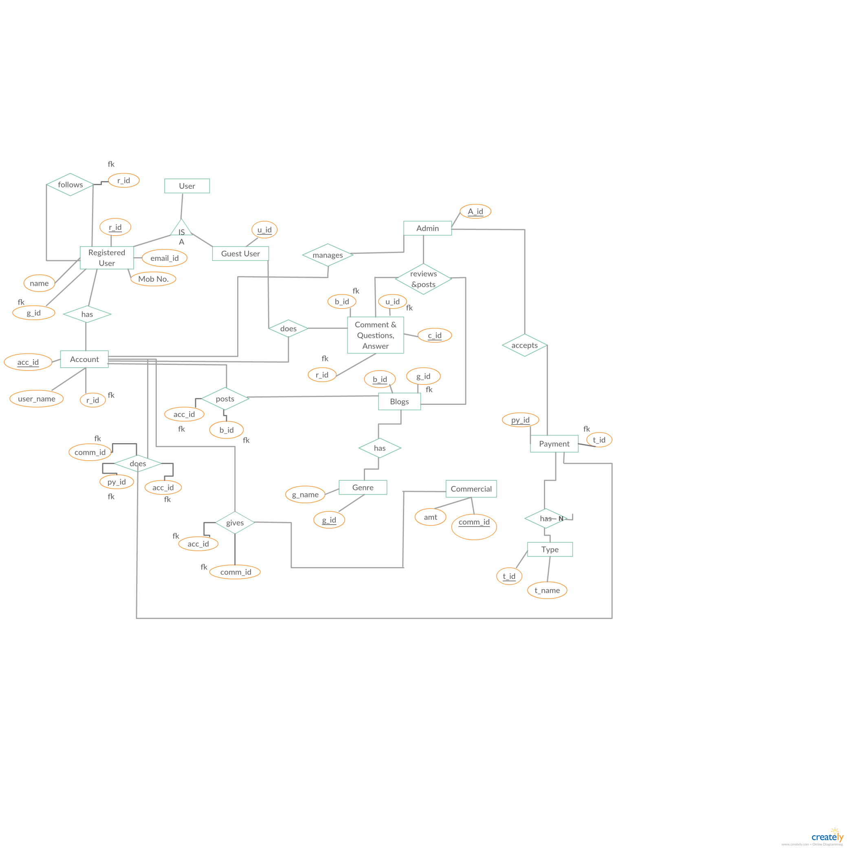

**5. DATA DICTIONARY**

**UserData:**

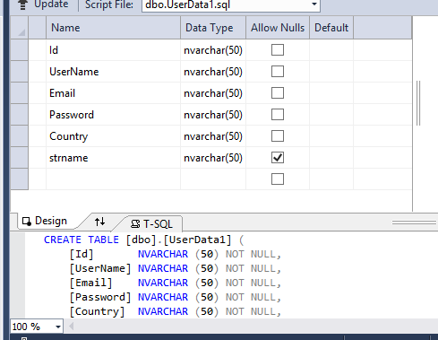

**Blogs:**

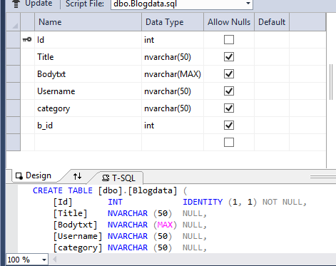

**Followers:**

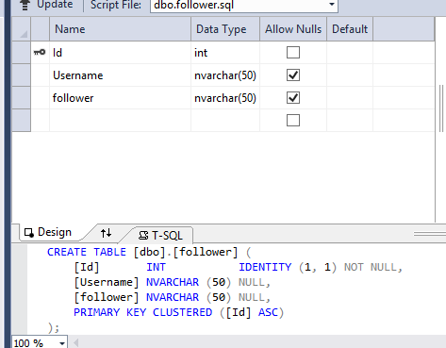

**Follow Request:**

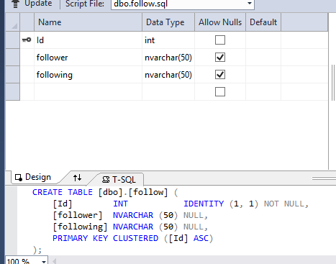

**Bill Details:**

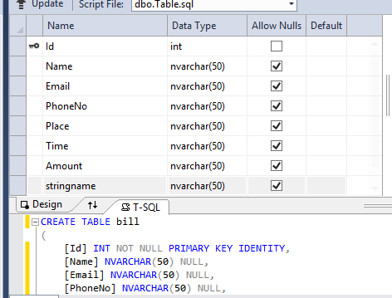

**Comments:**

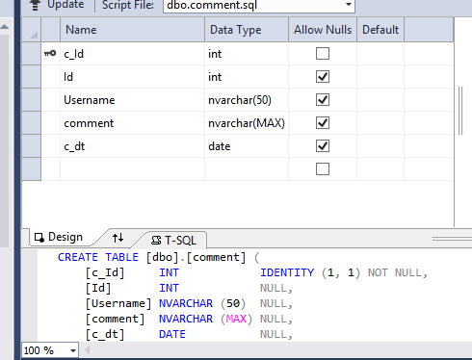

**Notifications:**

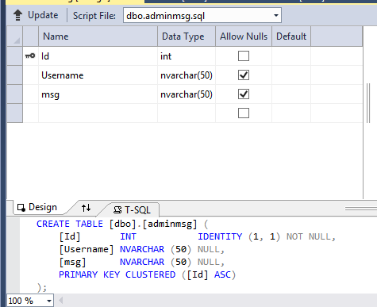

**4. SCREENSHOTS**

**Login:**

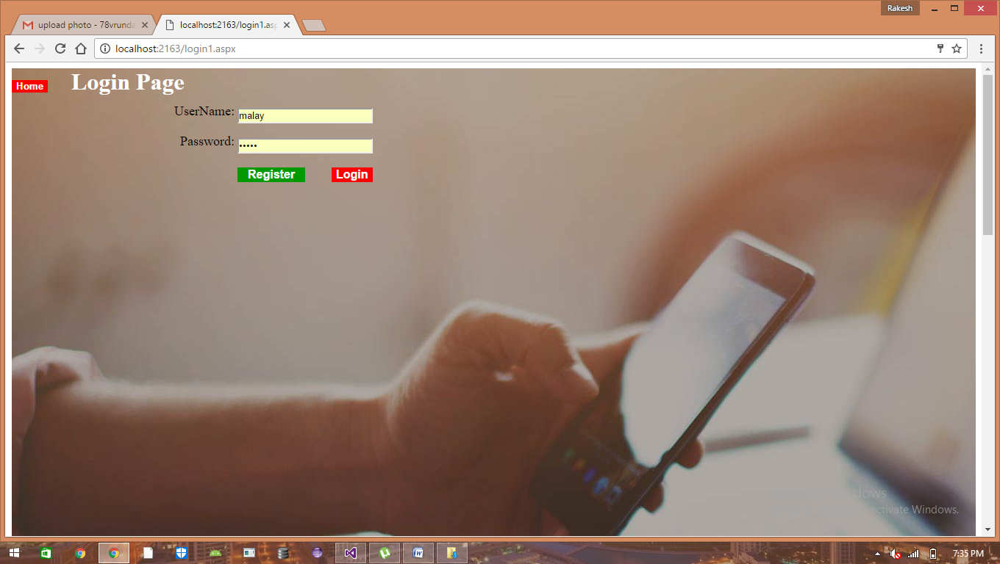

**Registration:**

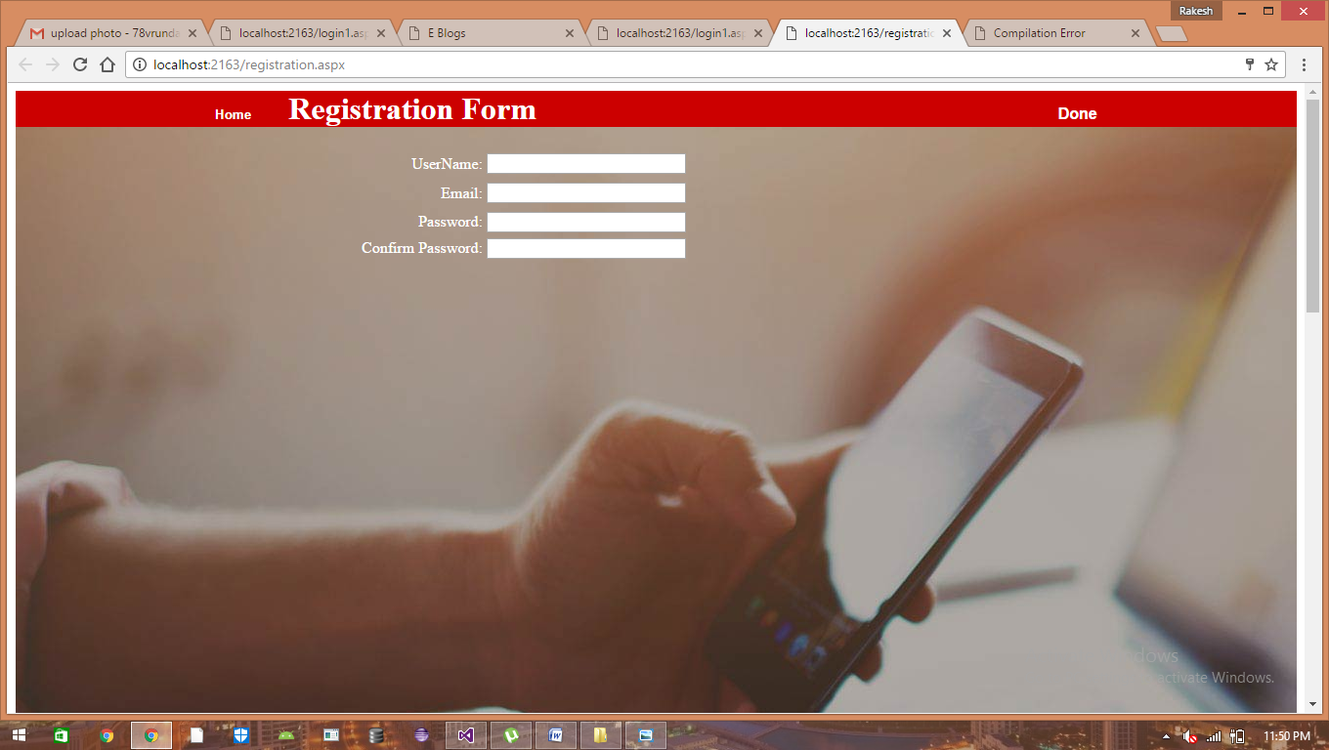

**Home:**

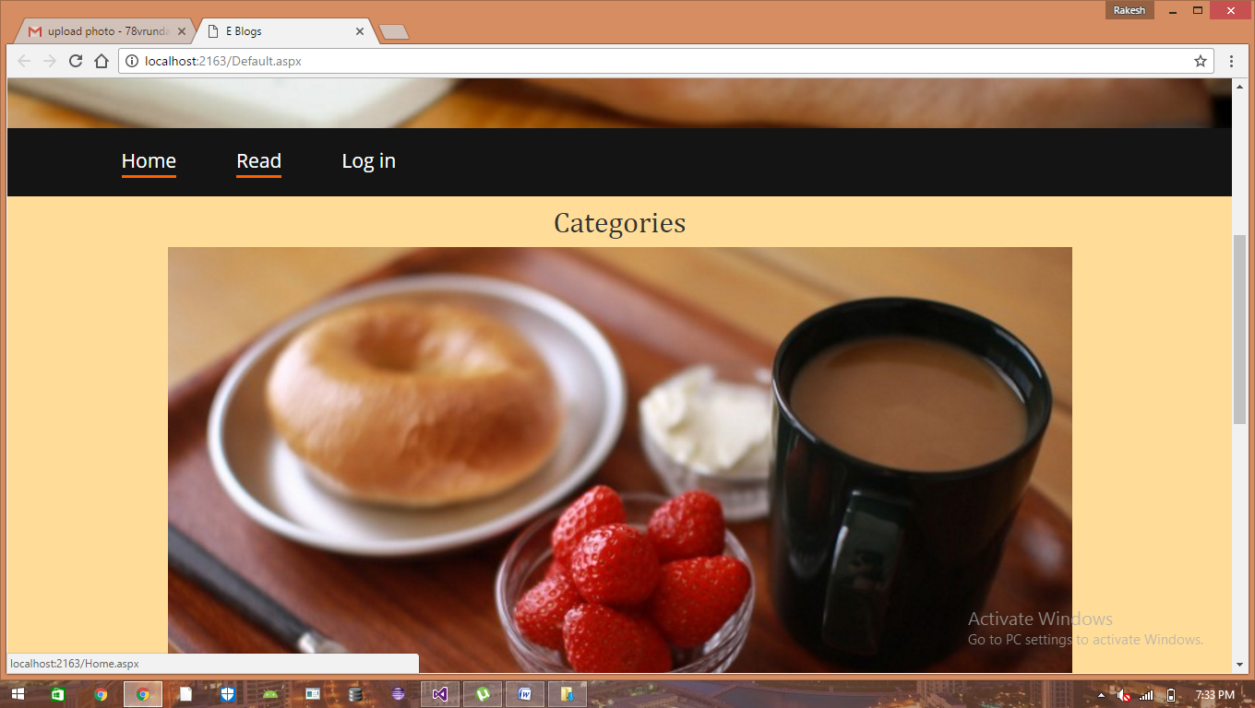

**Default:**

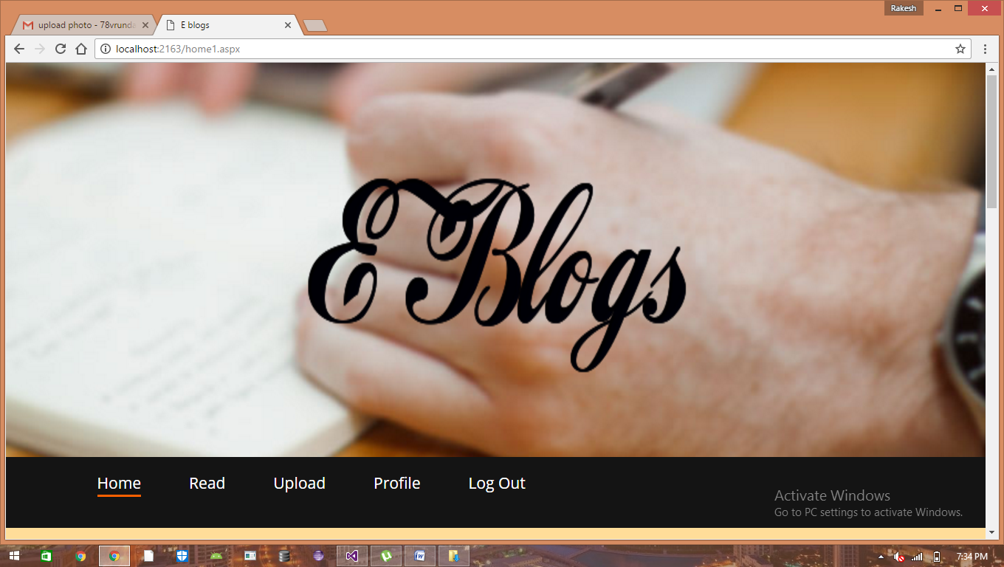

**Upload Blog:**

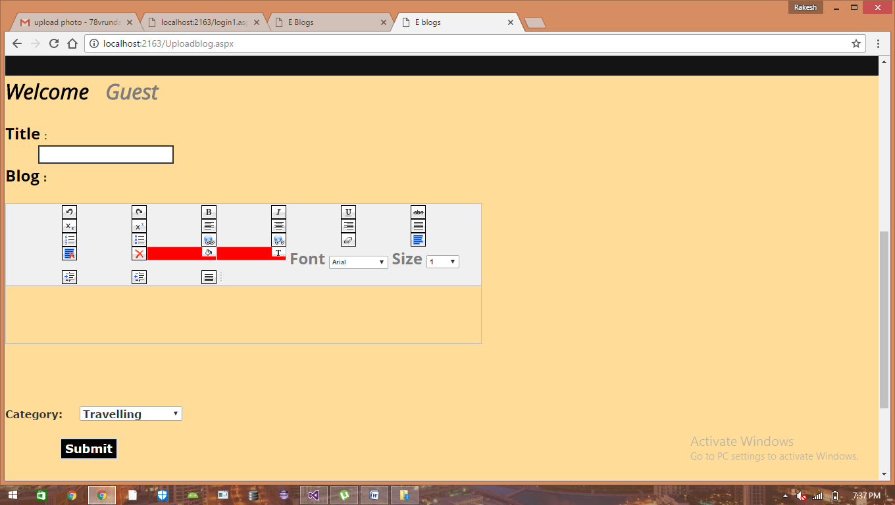

**Read Blog:**

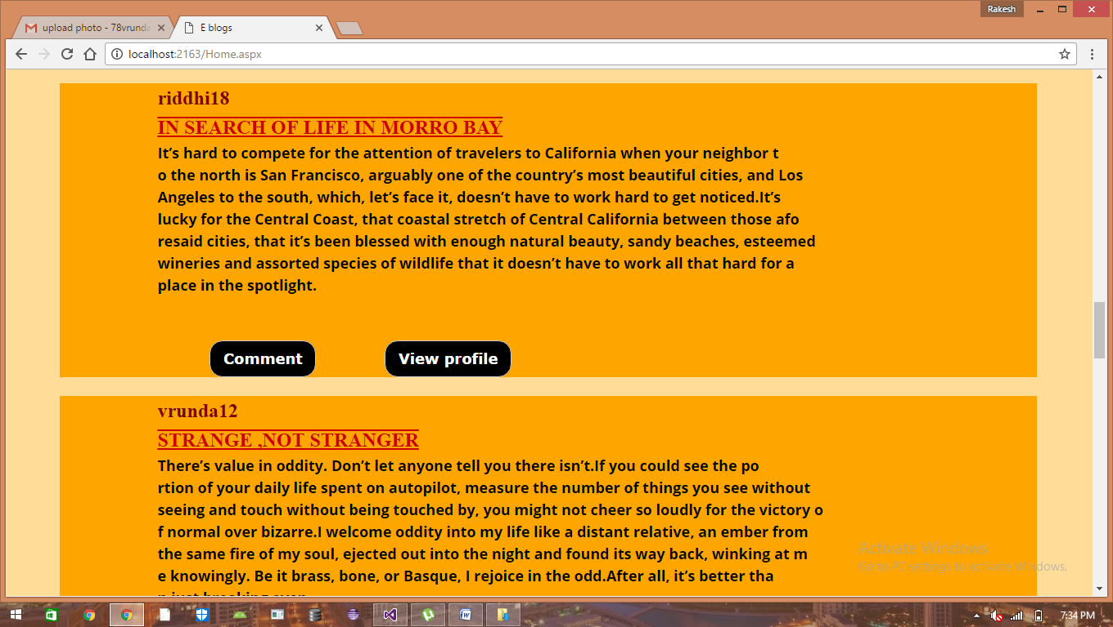

**Profile:**

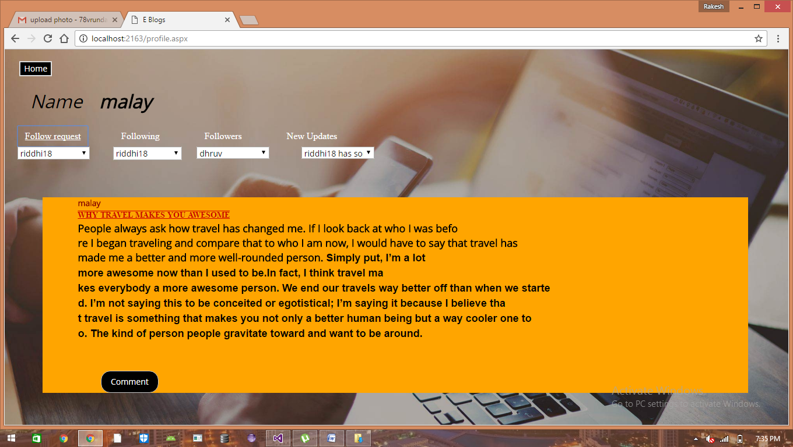

**Category:**

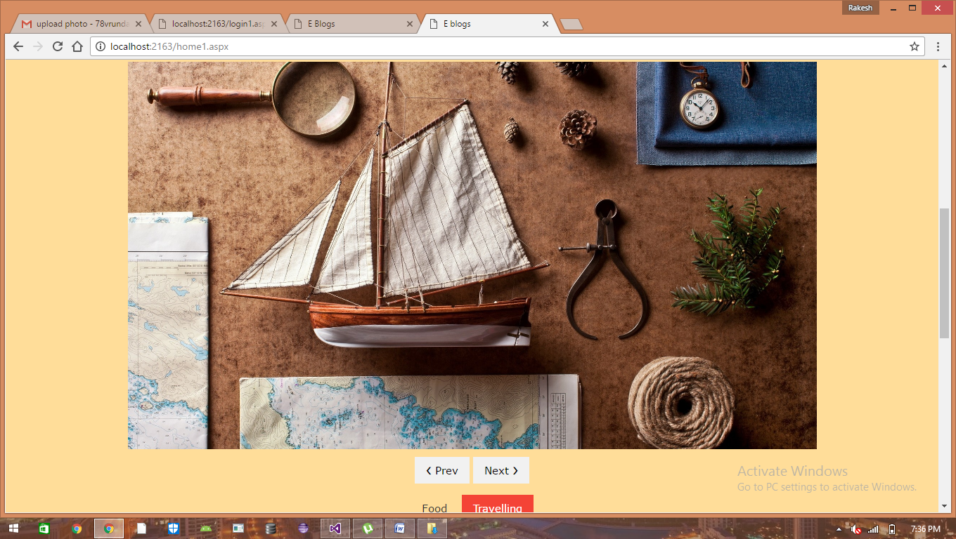

**View Profile:**

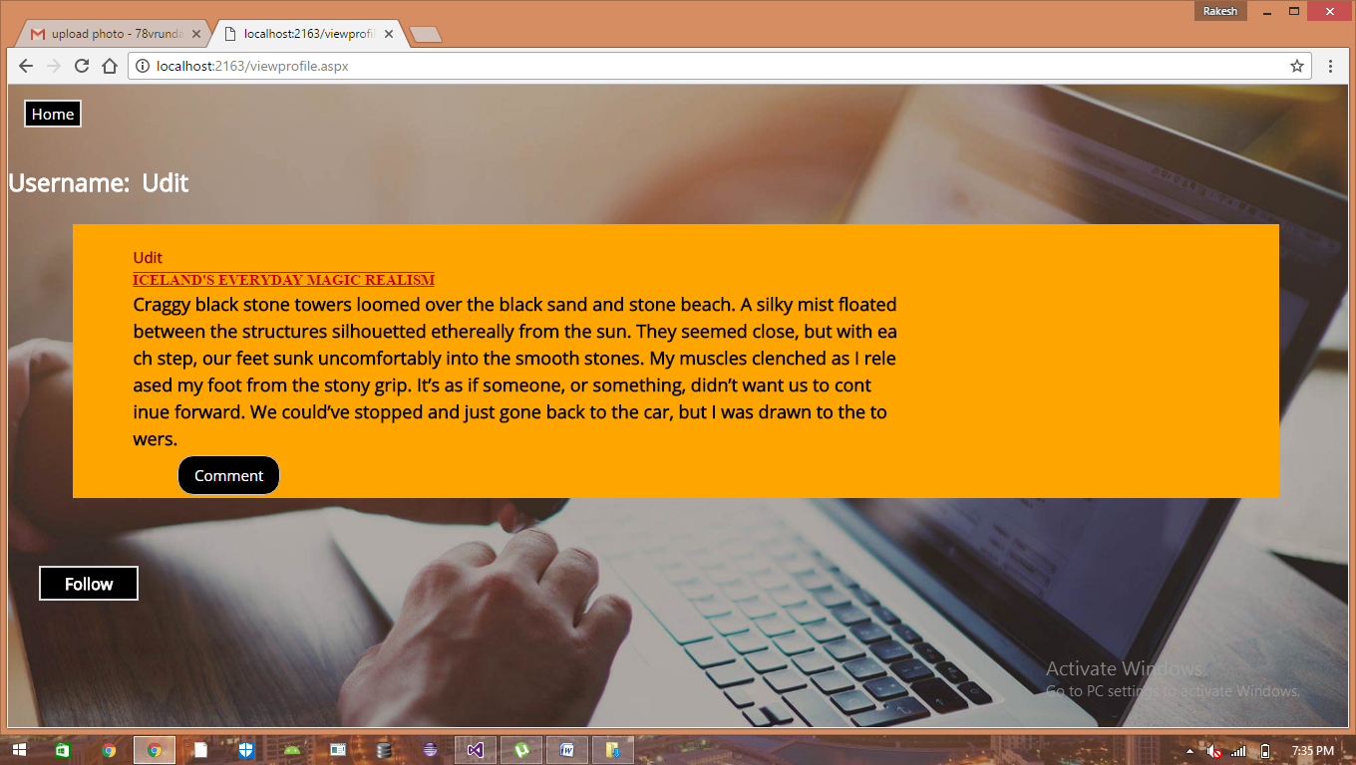

**Comment:**

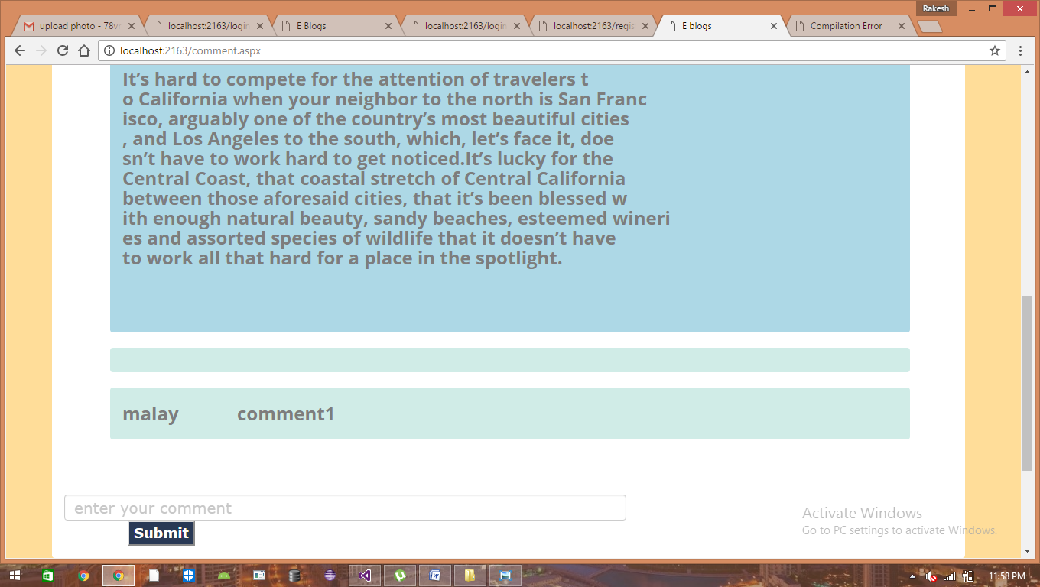

**Advertisements:**

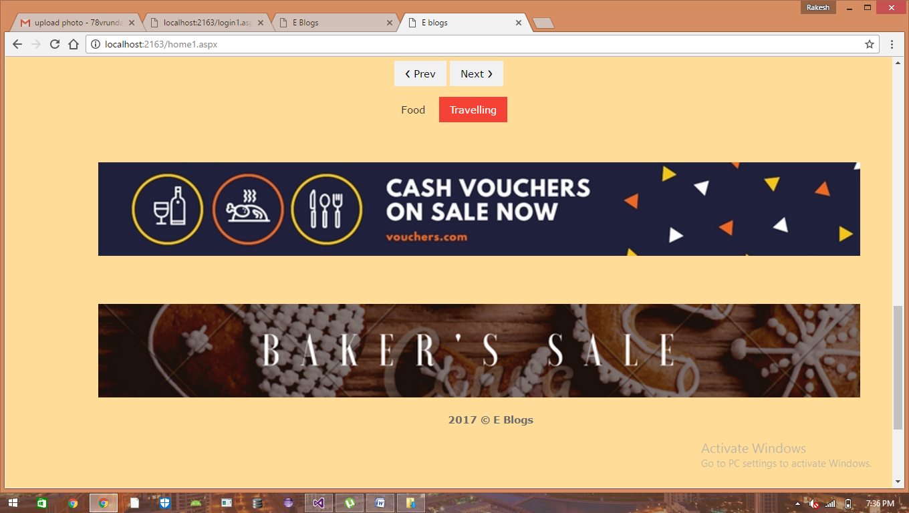

**Travelling blogs:**

